Library Management System Project Documentation
1. Assignment Description
Project Title: Library Management System
Overview:
This project simulates a small Library Management System that manages books, patrons, and transactions (borrowing and returning). It demonstrates Object-Oriented Programming (OOP) design and advanced C++ features in an integrated, real-world context.
Requirements:
The design requires four or more classes, OOP principles (inheritance, polymorphism, encapsulation), operator overloading, exception handling, collections (vectors, maps), file I/O, and enumerations.
Key Features:
- Classes: Book, Patron, Transaction, Library, DueDate, DueTime.
- Inheritance: `EBook` and `PrintedBook` inherit from the abstract base class `Book`.
- Polymorphism: Virtual methods like `displayInfo()` are overridden by child classes.
- File Operations: Loads and saves data for books, patrons, and transactions using CSV-style text files.
- Search: Functionality to search books by Author or Genre.
- Menu Interface: A console-based menu for user interaction.
---
2. Readme Documentation (Inputs and Outputs)
Inputs
The application accepts inputs from two primary sources: persistent storage files and user interaction via the console.
1. File Inputs (loaded at startup):
- `books.txt`: A CSV file containing book inventory.
- Format: `Genre,Title,Author,Type,ExtraData`
- _Example_: `Fiction,The Great Gatsby,F. Scott Fitzgerald,Printed,180`
- `patrons.txt`: A CSV file containing registered patrons.
- Format: `ID,Name`
- _Example_: `1,Jane Doe`
- `transactions.txt`: A CSV file containing transaction history.
- Format: `PatronID, BookTitle, Date, Time`

2. User Inputs (Console):
- Menu Selection: Integer (1-8) to navigate the application features.
- Patron Details: Integer ID and String Name when adding a patron or performing transactions.
- Book Details: String Title when checking out or returning books.
- Search Queries: String for Author search or Integer for Genre selection.

Outputs
The application produces outputs to the console for user interaction and updates the persistent storage files.
1. Console Outputs:
- Menu Display: A list of available operations.
- Inventory Lists: Formatted display of books (Title, Author, Genre, Status, Details).
- Patron Lists: Formatted display of patrons and their currently borrowed books.
- Search Results: Filtered lists of books based on Author or Genre.
- Status Messages: Success confirmations (e.g., "Saving and Exiting...") or Error messages (e.g., "Book not found").

2. File Outputs (saved on modification/exit):
- `books.txt`: Updated with new books or status changes (Available/Checked Out).
- `patrons.txt`: Updated with new patrons.
- `transactions.txt`: Appended with new checkout/return logs.
---

3. Application Pseudocode
START Program
INITIALIZE Library object

TRY
CALL Library.loadData()
OPEN "books.txt" -> READ and PARSE books -> Store in Book Vector
OPEN "patrons.txt" -> READ and PARSE patrons -> Store in Patron Map
OPEN "transactions.txt" -> READ and PARSE transactions -> Store in Transaction Vector
CATCH Exceptions
PRINT Error Message
EXIT Program

LOOP (Infinite until Exit chosen)
DISPLAY Menu Options:
1. View All Books
2. View All Patrons
3. Checkout Book
4. Return Book
5. Add Patron
6. Search by Author
7. Search by Genre
8. Exit

PROMPT User for Choice -> READ Choice

SWITCH (Choice)
CASE 1: CALL Library.displayBooks()
CASE 2: CALL Library.displayPatrons()
CASE 3:
PROMPT "Enter Patron ID" -> READ pid
PROMPT "Enter Book Title" -> READ title
TRY CALL Library.checkoutBook(pid, title)
CATCH Error -> PRINT Error
CASE 4:
PROMPT "Enter Patron ID" -> READ pid
PROMPT "Enter Book Title" -> READ title
TRY CALL Library.returnBook(pid, title)
CATCH Error -> PRINT Error
CASE 5:
PROMPT "Enter Name" -> READ name
PROMPT "Enter ID" -> READ id
CALL Library.addPatron(Patron(name, id))
CASE 6:
PROMPT "Enter Author" -> READ author
CALL Library.searchByAuthor(author)
CASE 7:
DISPLAY Genre Map (0:Fiction, 1:NonFiction, etc.)
PROMPT "Enter Genre ID" -> READ genreId
CALL Library.searchByGenre(genreId)
CASE 8:
PRINT "Saving and Exiting..."
CALL Library.saveData()
WRITE Book Vector -> "books.txt"
WRITE Patron Map -> "patrons.txt"
WRITE Transaction Vector -> "transactions.txt"
BREAK LOOP
DEFAULT: PRINT "Invalid Choice"
END SWITCH
END LOOP

RETURN 0

END Program
---

4. Flowchart, UML, and Use Case Diagrams
Flowchart
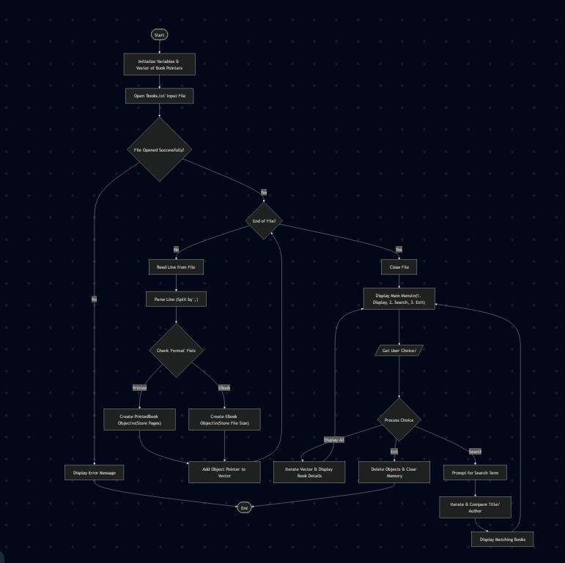
UML Class Diagram
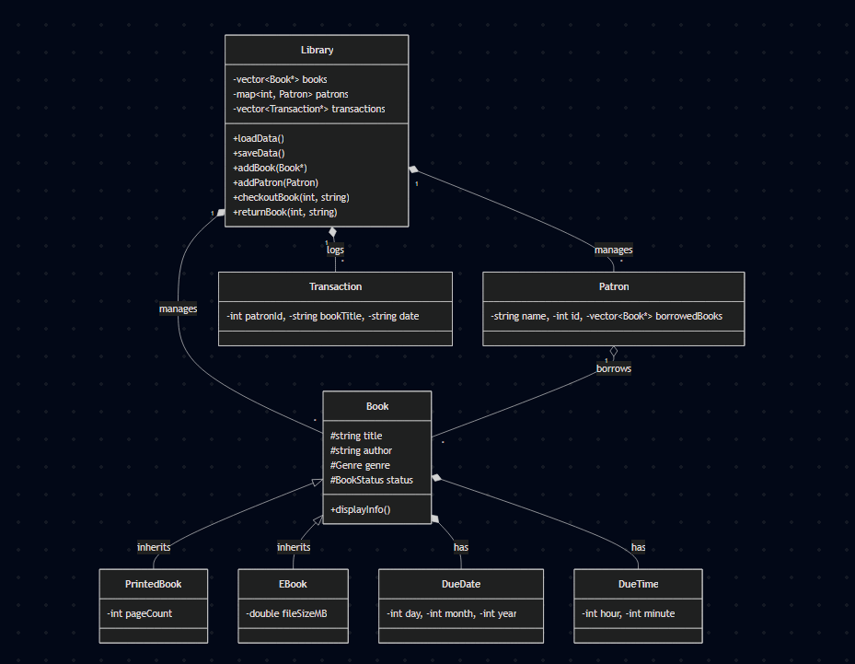
Use Case Diagram
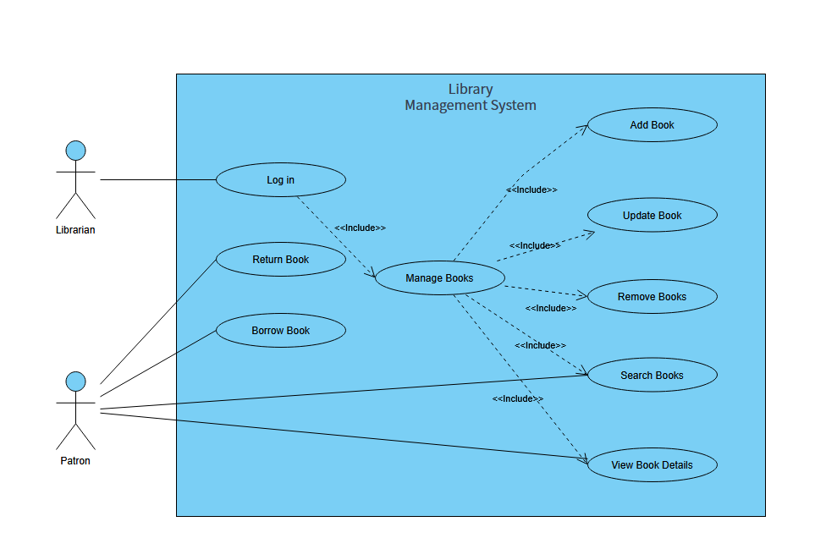
5. Source Code

Link to shared files: Final_Project

Library_Management_System.cpp
//SECTION - Include necessary header files
#include <iostream>
#include <stdexcept>
#include <string>

using namespace std;

//SECTION - Include project-specific headers for classes and functionality
#include "Book.h"
#include "EBook.h"
#include "Library.h"
#include "PrintedBook.h"
#include "Patron.h"
#include "Transaction.h"

//SECTION - Definition of the main function
int main() {
//SECTION - Initialize Library
Library library;

//SECTION - Menu-driven interface for user interaction
// The menu allows users to view books/patrons, check out/return books, add patrons, search by author/genre, and exit.
// Variable to store user choice in the menu
int choice;

//SECTION - Loop to display menu and process user input until exit option is chosen
// The loop continues until the user selects the exit option (choice 8).
do {
// Display menu options
cout << "\n--- Library Management System ---\n";
cout << "1. View All Books\n";
cout << "2. View All Patrons\n";
cout << "3. Checkout Book\n";
cout << "4. Return Book\n";
cout << "5. Add Patron\n";
cout << "6. Search by Author\n";
cout << "7. Search by Genre\n";
cout << "8. Exit\n";
cout << "Enter choice: ";

//SECTION - Input validation for menu choice
// If the input is not an integer, clear the error state and ignore the rest of the line, then continue to the next iteration of the loop to prompt again.
if (!(cin >> choice)) {
cin.clear();
cin.ignore(1000, '\n');
continue;
}
// Clear the input buffer after reading the choice to ensure subsequent inputs are processed correctly.
cin.ignore();

//SECTION - Process user choice using a switch statement
// Each case corresponds to a menu option and calls the appropriate function on the Library object.
// The try-catch block is used to handle any exceptions that may arise during the execution of the chosen operation, such as file I/O errors or invalid input.
try {
//SECTION - Switch statement to handle user choices and call corresponding Library functions
switch (choice) {

// Each case corresponds to a menu option and calls the appropriate function on the Library object.
//Case 1: Display all books in the library
case 1: {
library.displayBooks();
break;
}
//Case 2: Display all patrons registered in the library
case 2: {
library.displayPatrons();
break;
}
//Case 3: Checkout a book for a patron by ID and book title
case 3: {
int pid;
string title;
cout << "Enter Patron ID: ";
cin >> pid;
cin.ignore();
cout << "Enter Book Title: ";
getline(cin, title);
library.checkoutBook(pid, title);
break;
}

//Case 4: Return a book for a patron by ID and book title
case 4: {
int pid;
string title;
cout << "Enter Patron ID: ";
cin >> pid;
cin.ignore();
cout << "Enter Book Title: ";
getline(cin, title);
library.returnBook(pid, title);
break;
}

//Case 5: Add a new patron to the library by entering their name and ID
case 5: {
string name;
int id;
cout << "Enter Patron Name: ";
getline(cin, name);
cout << "Enter Patron ID: ";
cin >> id;
library.addPatron(Patron(name, id));
break;
}

//Case 6: Search for books by a specific author and display results
case 6: {
string author;
cout << "Enter Author Name: ";
getline(cin, author);
library.searchByAuthor(author);
break;
}

//Case 7: Search for books by genre and display results
case 7: {
// Simplified genre selection for demo
cout << "Genres: 0:Fiction, 1:NonFiction, 2:Mystery, 3:Science, 4:Biography\n";
int g;
cout << "Enter Genre ID: ";
cin >> g;
if (g >= 0 && g <= 4) library.searchByGenre(static_cast<Genre>(g));
else cout << "Invalid genre.\n";
break;
}

//Case 8: Exit the program, saving data before exiting
case 8:
cout << "Saving and Exiting...\n";
break;
default:
cout << "Invalid choice. Try again.\n";
}
}

//SECTION - Catch block to handle exceptions that may occur during library operations
// If an exception is thrown during any of the library operations (e.g., file I/O errors, invalid input), it will be caught here and an error message will be displayed to the user.
catch (const exception& e) {

//Display error message to the user if an exception occurs during library operations
cerr << "Error: " << e.what() << endl;
}
}

// The loop continues until the user selects the exit option (choice 8).
while (choice != 8);

//SECTION - Return 0 to indicate successful program termination
//End program
return 0;
};

Library.h
//SECTION - Header guard to prevent multiple inclusions of this header file
#ifndef LIBRARY_H
#define LIBRARY_H

//SECTION - Include necessary header files
#include <ctime>
#include <fstream>
#include <functional>
#include <iostream>
#include <map>
#include <random>
#include <sstream>
#include <stdexcept>
#include <string>

using namespace std;

//SECTION - Include project-specific headers for classes and functionality
#include "Book.h"
#include "EBook.h"
#include "PrintedBook.h"
#include "Patron.h"
#include "Transaction.h"

//SECTION - Library Class Definition
class Library {

//SECTION - Containers for records used by library management system
// Vector for book records
vector<Book*> books;

// Map for patron record pairs
map<int, Patron> patrons;

// Vector for transaction records
vector<Transaction*> transactions;

//SECTION - Public members for interface and functionality
public:

// Constructor for Library class
Library();

// Destructor for Library class
~Library();

// Function to load data from data files for necessary records
void loadData();

// Function to save data to data files for necessary records
void saveData();

// Function to add a new book to the library inventory
void addBook(Book* b);

// Function to add a new patron to the library catalog
void addPatron(const Patron& p);

// Function to checkout a book from the library inventory
void checkoutBook(int patronId, string title);

// Function to return a book to the library inventory
void returnBook(int patronId, string title);

// Function to display all books in the library inventory
void displayBooks() const;

// Function to display all patrons in the library catalog
void displayPatrons() const;

// Function to search for books by author
void searchByAuthor(const string& author) const;

// Function to search for books by genre
void searchByGenre(Genre genre) const;

//SECTION - Template for saving data to file
// Declares template for the function to save data to the file
template <typename Container, typename Func>

// Function declaration / definition for saving data to file
void saveToFile(const string& filename, const Container& items, Func formatter) {

// File stream variable to handle data management
ofstream file(filename);

// Validates if the data file opens successfully. If the file doesn't open, throw an exception letting the user know the file is not opened for writing.
if (!file) throw runtime_error("Failed to open " + filename + " for writing.");

// Loop to write arguments of function to file
for (const auto& item : items) {
file << formatter(item) << endl;
}
}
};

//SECTION - End of header guard
#endif

Library.cpp
//SECTION - Include necessary header files
#include <ctime>
#include <fstream>
#include <iostream>
#include <random>
#include <sstream>
#include <stdexcept>
#include <string>

using namespace std;

//SECTION - Include project-specific headers for classes and functionality
#include "Book.h"
#include "DueDate.h"
#include "DueTime.h"
#include "EBook.h"
#include "Library.h"
#include "PrintedBook.h"
#include "Patron.h"
#include "Transaction.h"

// SECTION - Helper function to return the genre of the book.
string genreToString(Genre g) {

// Switch statement to determine which genre is assigned to the book record.
switch(g) {
case Genre::Fiction: return "Fiction";
case Genre::NonFiction: return "NonFiction";
case Genre::Mystery: return "Mystery";
case Genre::Science: return "Science";
case Genre::Biography: return "Biography";
}
return "Unknown";
}

//SECTION - Library Constructor
//Constructor for the Library class
Library::Library() {

//Loads data from the books.txt, patrons.txt, and transactions.txt files using the loadData function
loadData();
};

//SECTION - Display Books function
void Library::displayBooks() const {

// Display all books in the library
cout << "Books in Library:" << endl;

// Loop to display books
for (const Book* b : books) {
cout << *b << endl;
}
};

//SECTION - Add Book function
void Library::addBook(Book* b) {

// Add a new book to the library
books.push_back(b);

// Uses saveData function to save list of books
saveData();

// Uses displayBooks function to display list of books after saving changes
displayBooks();
};

//SECTION - Display Patrons function
void Library::displayPatrons() const {

// Display all patrons in the library
cout << "Patrons in Library:" << endl;

// Loop to display patrons
for (const auto& pair : patrons) {
cout << pair.second << endl;
}
};

//SECTION - Add Patron function
void Library::addPatron(const Patron& p) {

// Add a new patron to the library
patrons.emplace(p.getId(), p);

// Uses saveData function to save list of patrons
saveData();

// Uses displayPatrons function to display list of patrons after saving changes
displayPatrons();
};

//SECTION - Load Data function
void Library::loadData() {

//SECTION - Load book data from file
// Open books.txt data file using filestream. If the file does not open, throw an exception.
std::ifstream file("books.txt");
if (!file) throw std::runtime_error("Failed to open books file.");

// Variable to hold data from the file
string line;

// Loop to read data from the file
while (getline(file, line)) {

// Validate if the file is empty. If the file is empty, continue loading data.
if (line.empty() == true) continue;

// Read data from the file and store it in the temporary variable.
stringstream ss(line);

// Variables to format/parse data from the file into the data members for the book class.
string genreStr, title, author, typeStr, extraStr;

// Parse data from temporarily stored data into data members from the book class
getline(ss, genreStr, ',');
getline(ss, title, ',');
getline(ss, author, ',');
getline(ss, typeStr, ',');
getline(ss, extraStr, ',');

// Variable to temporarily store genre from data file
Genre g = Genre::Fiction;

// If statements to determine the genre of the book
if (genreStr == "NonFiction") g = Genre::NonFiction;
else if (genreStr == "Mystery") g = Genre::Mystery;
else if (genreStr == "Science") g = Genre::Science;
else if (genreStr == "Biography") g = Genre::Biography;
else if (genreStr == "Fiction") g = Genre::Fiction;

// If statements to determine the type of the book.
// Added try/catch validation to resolve error with stoi/stod conversion
try {
if (typeStr == "Printed") {
books.push_back(new PrintedBook(title, author, g, stoi(extraStr)));
} else if (typeStr == "EBook") {
books.push_back(new EBook(title, author, g, stod(extraStr)));
}
} catch (...) {
continue;
}
}

//SECTION - Load patron data from file
std::ifstream patronFile("patrons.txt");

// Open patrons.txt data file using filestream. If the file does not open, throw an exception.
if (!patronFile) throw std::runtime_error("Failed to open patrons file.");

// Loop to read data from the file
while (getline(patronFile, line)) {

// Validate if the file is empty. If the file is empty, continue loading data. If the file is not empty, displays the contents of the file and exits the program.
if (line.empty() == true) continue;

// Read data from the file and store it in the temporary variable.
stringstream ss(line);

// Variables to format/parse data from the file into the data members for the patron class.
string idStr, name;

// Parse data from temporarily stored data into data members from the patron class
getline(ss, idStr, ',');

// Read rest of line as name
getline(ss, name);
if (!idStr.empty() && !name.empty()) {
try {
int id = stoi(idStr);
patrons.emplace(id, Patron(name, id));
} catch (...) {
continue;
}
}
}

//SECTION - Load transaction data from file
std::ifstream transactionFile("transactions.txt");

// Transactions are optional on first run, so don't throw if missing
if (transactionFile) {

// Loop to read data from the file
while (getline(transactionFile, line)) {

// Validate if the file is empty. If the file is empty, continue loading data. If the file is not empty, displays the contents of the file and exits the program.
if (line.empty() == true) continue;

// Read data from the file and store it in the temporary variable.
stringstream ss(line);

// Variables to format/parse data from the file into the data members for the transaction class.
string pidStr, bookTitle, dateStr;

// Parse data from temporarily stored data into data members from the transaction class
getline(ss, pidStr, ',');
getline(ss, bookTitle, ',');
getline(ss, dateStr);

// If the transactions file is not empty, add a new transaction at the end of the file.
if (!pidStr.empty()) {
try {
transactions.push_back(new Transaction(stoi(pidStr), bookTitle));
} catch (...) {
continue;
}
}
}
}
};

//SECTION - Checkout Book function
void Library::checkoutBook(int patronId, string title) {

// Validate patron exists
auto it = patrons.find(patronId);
if (it == patrons.end()) {
throw runtime_error("Patron ID not found.");
}

// Loop to find patron and book, update book status, and log transaction.
for (Book* b : books) {

// Validate the book exists in the library
if (b->getTitle() == title) {

// Validate status of book. If not checked out, changes status to checked out.
if (b->getStatus() == BookStatus::Available) {
b->setStatus(BookStatus::CheckedOut);

// Add the book to the patron's borrowed list
it->second.borrowBook(b);

// Log transaction showing change from available to checked out.
transactions.push_back(new Transaction(patronId, title));
saveData();
return;
}

// If book is already checked out, throw an exception stating the book is already checked out.
else if (b->getStatus() == BookStatus::CheckedOut) {
throw runtime_error("Book is already checked out.");
}

// If book is not available, throw an exception stating the book is not available.
else {
throw runtime_error("Book is not available.");
}
}
}

// If the book does not exist in the library, throw an exception stating the book cannot be found.
throw runtime_error("Book not found in library inventory.");
};

//SECTION - Return Book function
void Library::returnBook(int patronId, string title) {

// Validate patron exists
auto it = patrons.find(patronId);
if (it == patrons.end()) {
throw runtime_error("Patron ID not found.");
}

// Loop to get list of books in library inventory.
for (Book* b : books) {

// Validate the book being returned exists in the library AND is in a checked out status
if (b->getTitle() == title && b->getStatus() == BookStatus::CheckedOut) {

// Change the book status back to available
b->setStatus(BookStatus::Available);

// Attempt to remove the book from the patron's borrowed list.
// We use a try-catch block here because if the program was restarted,
// the patron's runtime list might be empty even if the book is checked out.
try {
it->second.returnBook(b);
} catch (...) {
// Ignore error if book not found in patron's list (e.g. persistence gap)
}

// Log transaction showing change from checked out to available.
transactions.push_back(new Transaction(patronId, title, true));
saveData();
return;
}
}

// If the book does not exist in the library inventory, or the book is not in a checked out status, throw an exception.
throw runtime_error("Book not found or not checked out.");
};

//SECTION - Save Data function
void Library::saveData() {
//SECTION - Save books to data file using a template
saveToFile("books.txt", books, [](Book* b) {

// Variable to handle stream management
stringstream ss;

// Uses the helper function to determine the genre of the book. Adds this data member to the stream.
ss << genreToString(b->getGenre()) << ",";

// Adds the book's Title data member to the stream.
ss << b->getTitle() << ",";

// Adds the book's Author data member to the stream.
ss << b->getAuthor() << ",";

// Validate whether the book is of class printed or ebook, then adds the page count for the book/ebook to the stream. If the class is ebook, it also adds the ebook's file size to the stream.
if (auto pb = dynamic_cast<PrintedBook*>(b)) {
ss << "Printed," << pb->getPageCount();
} else if (auto eb = dynamic_cast<EBook*>(b)) {
ss << "EBook," << eb->getFileSize();
}

// Returns the full stream as a string
return ss.str();
});

//SECTION - Save patrons using template
// Function to save the patron in the data file as a pair, based on the patron id number.
saveToFile("patrons.txt", patrons, [](const pair<const int, Patron>& pair) {
const Patron& p = pair.second;
return to_string(p.getId()) + "," + p.getName();
});

//SECTION - Save transactions using template
// Function to save the transaction in the data file as a string using the patron id, the book title, the date of the transaction, and the time of the transaction.
saveToFile("transactions.txt", transactions, [](Transaction* t) {
return to_string(t->patronId) + "," + t->bookTitle + "," + t->date+ "," + t->transactionTime;
});
};

//SECTION - Library Destructor
// Destructor for the library class
Library::~Library() {

// Saves all records to associated data files.
saveData();

// Loop to clear data file holding record of books. Then clears vector in program holding same records.
for (Book* b : books) {delete b;}
books.clear();

// Loop to clear vector holding record of transactions.
for (Transaction *t : transactions) {delete t;}
transactions.clear();

// Clears vector holding record of patrons.
patrons.clear();

};

//SECTION - Search function - Author
// Search library inventory by author
void Library::searchByAuthor(const string& author) const {

// Displays text to user that search will be conducted by author.
cout << "Searching for author: " << author << endl;

// Variable to track if a book has been found by the search function
bool found = false;

// Loop to search through the inventory of books
for (const Book* b : books) {

// If the author is found, displays the book title.
if (b->getAuthor().find(author) != string::npos) {
cout << *b << endl;
found = true;
}
}

// If no books are found in the inventory, displays a message to the user indicating this result.
if (!found) cout << "No books found by this author." << endl;
}

//SECTION - Search function
// Search library inventory by genre
void Library::searchByGenre(Genre genre) const {

// Displays text to user that search will be conducted by genre.
cout << "Searching for genre: " << genreToString(genre) << endl;

// Loop to search through the inventory of books
for (const Book* b : books) {

// If the genre is found, displays the book title.
if (b->getGenre() == genre) {
cout << *b << endl;
}
}
}

Book.h
//SECTION - Header guard to prevent multiple inclusions of this header file
#ifndef BOOK_H
#define BOOK_H

//SECTION - Include necessary header files
#include <iostream>
#include <string>
#include <vector>

using namespace std;

//SECTION - Include project-specific headers for classes and functionality
#include "DueDate.h"
#include "DueTime.h"

//SECTION - Enumerations for Book properties

//Genre enumeration to categorize books into different genres.
enum class Genre { Fiction, NonFiction, Mystery, Science, Biography };

//BookStatus enumeration to indicate whether a book is available or checked out.
enum class BookStatus { Available, CheckedOut };

//BookType enumeration to differentiate between printed books and eBooks.
enum class BookType { Printed, EBook };

//SECTION - Book Class Definition
class Book {
//SECTION - Protected members to allow access in derived classes
protected:

//Title of the book.
string title;

//Author of the book.
string author;

//Genre of the book, using the Genre enumeration.
Genre genre;

//Status of the book, using the BookStatus enumeration.
BookStatus status;

//Type of the book, using the BookType enumeration.
BookType type;

//Page count of the book.
int pageCount;

//Due date for when the book is checked out.
DueDate dueDate;

//Due time for when the book is checked out.
DueTime dueTime;

//SECTION - Public members for interface and functionality
public:
//Constructor for the Book class.
Book(Genre g, string t, string a, BookType bt, int p);

//Destructor for the Book class.
virtual ~Book();

//Virtual function to display book information, can be overridden by derived classes.
virtual void displayInfo() const;

//Setter for the status of the book (Available or CheckedOut).
void setStatus(BookStatus s);

//Getter for the current status of the book.
BookStatus getStatus() const;

//Getter for the title of the book.
string getTitle() const { return title; };

//Getter for the author of the book.
string getAuthor() const { return author; };

//Getter for the genre of the book.
Genre getGenre() const { return genre; };

//Getter for the page count of the book.
int getPageCount() const { return pageCount; };

//Getter for the due date of the book.
DueDate getDueDate() const { return dueDate; };

//Getter for the due time of the book.
DueTime getDueTime() const { return dueTime; };

//Overloaded equality operator to compare two books based on their title, author, and genre.
bool operator==(const Book& other) const;

//Overloaded output stream operator to display book information when using cout.
friend ostream& operator<<(ostream& os, const Book& b);

//Friend classes that can access private and protected members of Book.
friend class Library;
friend class Patron;
friend class Transaction;
friend class PrintedBook;
friend class EBook;
};

//SECTION - End of header guard
#endif

Book.cpp
//SECTION - Include necessary header files
#include <iostream>
#include <string>
#include <vector>

using namespace std;

//SECTION - Include project-specific headers for classes and functionality
#include "Book.h"
#include "DueDate.h"
#include "DueTime.h"
#include "EBook.h"

//SECTION - Book Constructor
// The constructor initializes the book's title, author, genre, type, and sets the initial status to Available. It also initializes the due date and time to default values (1/1/2024 at 12:00).
Book::Book(Genre g, string t, string a, BookType bt, int p) : genre(g),title(t), author(a), type(bt), status(BookStatus::Available), pageCount(p), dueDate(1, 1, 2024), dueTime(12, 0) {};

//SECTION - Display Information function
// This function displays the book's information, including title, author, genre, and status. If the book is checked out, it also displays the due date and time.
void Book::displayInfo() const {

// Display book information: title, author, genre, and status. If the book is checked out, also display due date and time.
cout << "Title: " << title << "\nAuthor: " << author << "\nGenre: ";

//Switch statement to convert Genre enum to string for display purposes.
switch (genre) {
case Genre::Fiction: cout << "Fiction"; break;
case Genre::NonFiction: cout << "Non-Fiction"; break;
case Genre::Mystery: cout << "Mystery"; break;
case Genre::Science: cout << "Science"; break;
case Genre::Biography: cout << "Biography"; break;
}
cout << "\nStatus: " << (status == BookStatus::Available ? "Available" : "Checked Out") << endl;

// If the book is checked out, display the due date and time.
if (status == BookStatus::CheckedOut) {
cout << "Due Date: " << dueDate << "\nDue Time: " << dueTime << endl;
}
cout << endl;
};

//SECTION - Setters and Getters
//Function to set the status of the book (Available or CheckedOut).
void Book::setStatus(BookStatus s) {
status = s;
};

//Function to return the current status of the book.
BookStatus Book::getStatus() const {
return status;
};

//SECTION - Operator Overloading
//Overload the equality operator to compare two books based on their title, author, and genre.
bool Book::operator==(const Book& other) const {
return title == other.title && author == other.author && genre == other.genre;
};

//Overload the output stream operator to display book information when using cout.
ostream& operator<<(ostream& os, const Book& b) {
b.displayInfo();
return os;
};

//SECTION - Book Destructor
// The destructor for the Book class. Since there are no dynamically allocated resources, it can be left empty.
Book::~Book() {};

PrintedBook.h
#ifndef PRINTEDBOOK_H
#define PRINTEDBOOK_H

//SECTION - Include necessary header files
#include <string>
#include <iostream>

using namespace std;

//SECTION - Include project-specific headers for classes and functionality
#include "Book.h"

//SECTION - PrintedBook Class Definition
class PrintedBook : public Book {

//SECTION - Public members for interface and functionality
public:

//Constructor for the PrintedBook class
PrintedBook(string t, string a, Genre g, int p);

//Destructor for the PrintedBook class
~PrintedBook();

//Function to display the book's information
void displayInfo() const override;
};

//SECTION - End of header guard
#endif

PrintedBook.cpp
//SECTION - Include necessary header files
#include <iostream>
#include <string>

using namespace std;

//SECTION - Include project-specific headers for classes and functionality
#include "Book.h"
#include "PrintedBook.h"

//SECTION - PrintedBook Constructor
// Constructor for the PrintedBook class
PrintedBook::PrintedBook(string t, string a, Genre g, int p) : Book(g, t, a, BookType::Printed, p) {};

//SECTION - Display Information function
void PrintedBook::displayInfo() const {
// Uses the display info function from the Book base class to display the book's info. Also add's the page count for the book.
Book::displayInfo();
cout << "Page Count: " << pageCount << endl;
};

//SECTION - PrintedBook Destructor
// Destructor for the PrintedBook class
PrintedBook::~PrintedBook() {};

EBook.h
//SECTION - Header guard to prevent multiple inclusions of this header file
#ifndef EBOOK_H
#define EBOOK_H

//SECTION - Include necessary header files
#include <iostream>
#include <string>

using namespace std;

//SECTION - Include project-specific headers for classes and functionality
#include "Book.h"

//SECTION - EBook Class Definition
class EBook : public Book {
//SECTION - Data member to store the file size of the EBook
double fileSizeMB;

//SECTION - Public members for interface and functionality
public:
//Constructor for the EBook class
EBook(string t, string a, Genre g, double size);

//Destructor for the EBook class
~EBook();

//function to display the EBook's information
void displayInfo() const override;

//function to return the file size of the EBook
double getFileSize() const { return fileSizeMB; }
};

#endif

Ebook.cpp
//SECTION - Include necessary header files
#include <iostream>
#include <string>

using namespace std;

//SECTION - Include project-specific headers for classes and functionality
#include "Book.h"
#include "EBook.h"

//SECTION - Constructor for the EBook class
//Uses the Book base class to create a Book of type EBook
EBook::EBook(string t, string a, Genre g, double size) : Book(g, t, a, BookType::EBook, 0), fileSizeMB(size) {};

//SECTION - Display Information function
// This function uses the Book base class's function to display the EBook's info, adding File Size using the getFileSize function
void EBook::displayInfo() const {
Book::displayInfo();
cout << "File Size: " << EBook::getFileSize() << " MB" << endl;
};

//SECTION - Destructor for the EBook class
EBook::~EBook() {};

Patron.h
#ifndef PATRON_H
#define PATRON_H

//SECTION - Include necessary header files
#include <algorithm>
#include <iostream>
#include <stdexcept>
#include <string>
#include <vector>

using namespace std;

//SECTION - Include project-specific headers for classes and functionality
#include "Book.h"
#include "DueDate.h"
#include "DueTime.h"

//SECTION - Patron Class Definition
class Patron {

//SECTION - Private Data Members for the Patron class
// Data members for the patron name and ID
string name;
int id;

// Vector to hold the list of books borrowed by a patron
vector<Book*> borrowedBooks;

//SECTION - Public members for interface and functionality
public:

// Constructor for Patron class
Patron(string n, int i);

// Destructor for Patron class
~Patron() {};

// Getter for the patron's name
string getName() const { return name; }

// Getter for the patron's name
int getId() const { return id; }

// Function to borrow a book from the library inventory
void borrowBook(Book* b);

// Function to return a book to the library inventory
void returnBook(Book* b);

// Function to display a patron's information
void displayPatron() const;

// overload == operator to compare two patrons' info
bool operator==(const Patron& other) const;

// overload << operator to display patron info using cout
friend ostream& operator<<(ostream& os, const Patron& p);
};

//SECTION - End of header guard
#endif

Patron.cpp
//SECTION - Include necessary header files
#include <algorithm>
#include <iostream>
#include <stdexcept>
#include <string>
#include <vector>

using namespace std;

//SECTION - Include project-specific headers for classes and functionality
#include "Book.h"
#include "DueDate.h"
#include "DueTime.h"
#include "Patron.h"

//SECTION - Patron Constructor
Patron::Patron(string n, int i) : name(n), id(i) {};

//SECTION - Borrow Book function
void Patron::borrowBook(Book* b) {
// Add book record to list of books borrowed by a patron
borrowedBooks.push_back(b);
};

//SECTION - Return Book function
// Remove book record from list of books borrowed by a patron
void Patron::returnBook(Book* b) {
auto it = find(borrowedBooks.begin(), borrowedBooks.end(), b);
// Validate if all books have been returned by patron
if (it != borrowedBooks.end()) {

// If all books have not been returned, remove book being returned from list of borrowed books
borrowedBooks.erase(it);
}

// If all books have been returned, throw an exception letting the user know there are no more borrowed books for the selected patron
else {
throw runtime_error("Book not found in list of borrowed books.");
}
};

//SECTION - Display Patron function
// Function to display the patron's name, the patron's ID, and the list of books borrowed by the patron
void Patron::displayPatron() const {
cout << "Name: " << name << "\nID: " << id << endl;
cout << "Borrowed Books:" << endl;

// Loop to display the books borrow by the patron
for (const Book* b : borrowedBooks) {
cout << *b << endl;
}
};

//SECTION - Operator Overloading
//Overload the equality operator to compare two patrons based on their name and ID.
bool Patron::operator==(const Patron& other) const {
return name == other.name && id == other.id;
};

// Overload the output operator to display the patron's information in a readable format when using cout.
ostream& operator<<(ostream& os, const Patron& p) {
p.displayPatron();
return os;
};

Transaction.h
#ifndef TRANSACTION_H
#define TRANSACTION_H

//SECTION - Include necessary header files
#include <ctime>
#include <iostream>
#include <string>

using namespace std;

//SECTION - Transaction Class Definition
class Transaction {
//SECTION - Private Data Members for the Transaction class
// Adds library as friend class to allow access to private data members
friend class Library;

// Data member for the patron ID
int patronId;

// Data member for the book title
string bookTitle;

// Data members for the date and time of the transaction
string date;
string transactionTime;

//SECTION - Public members for interface and functionality
public:
// Constructor for the Transaction class
Transaction(int pid, string bt, bool isReturn = false);

// Function to display the transaction information
void displayTransaction() const;

// Destructor for the Transaction class
~Transaction();
};

//SECTION - End of header guard
#endif

Transaction.cpp
//SECTION - Include necessary header files
#include <ctime>
#include <iostream>
#include <string>

using namespace std;

//SECTION - Include project-specific headers for classes and functionality
#include "Transaction.h"

//SECTION - Transaction Constructor
// Constructor for the Transaction class
Transaction::Transaction(int pid, string bt, bool isReturn) : patronId(pid), bookTitle(bt) {

// Get current date and time
time_t now = time(0);
date = ctime(&now);

// Validate if the transaction is a return or a checkout. Adds the type of transaction to the date/time.
if (isReturn) {
date += " (Return)";
} else {
date += " (Checkout)";
}

//Removes trailing newline
date.pop_back();
};

//SECTION - Display Transaction function
// Function to display the transaction information
void Transaction::displayTransaction() const {
// Display the patron ID, book title, date, and time of the transaction
cout << "Patron ID: " << patronId << "\nBook Title: " << bookTitle << "\nDate: " << date << "\nTime: " << transactionTime << endl;
};

//SECTION - Destructor for the Transaction class
// The destructor for the Transaction class. Since there are no dynamically allocated resources, it can be left empty.
Transaction::~Transaction() {};

DueDate.h
//SECTION - Header guard to prevent multiple inclusions of this header file
#ifndef DUEDATE_H
#define DUEDATE_H

//SECTION - Include necessary header files
#include <iostream>
#include <stdexcept>

using namespace std;

//SECTION - DueDate Class Definition
class DueDate {
//SECTION - Data members to store the day, month, and year of the due date.
int day;
int month;
int year;

//SECTION - Public members for interface and functionality
public:

//Constructor for the DueDate class.
DueDate(int d, int m, int y);

//Destructor for the DueDate class.
~DueDate();

//function to display the due date in a readable format.
void displayDate() const;

//Overload the output stream operator to display the date in a readable format when using cout.
friend ostream& operator<<(ostream& os, const DueDate& d);
};

//SECTION - End of header guard
#endif

DueDate.cpp
//SECTION - Include necessary header files
#include <iostream>
#include <stdexcept>

using namespace std;

//SECTION - Include project-specific headers for classes and functionality
#include "DueDate.h"

//SECTION - DueDate Constructor
DueDate::DueDate(int d, int m, int y) : day(d), month(m), year(y) {
// Validate the date to ensure it is a valid calendar date. If the date is invalid, throw an exception.
if (d < 1 || d > 31 || m < 1 || m > 12 || y < 1) {
throw invalid_argument("Invalid date.");
}
};

//SECTION - Display Date function
//Display the date in Day/Month/Year format
void DueDate::displayDate() const {
cout << day << "/" << month << "/" << year;
};

//SECTION - Operator Overloading
//Overload the output stream operator to display the date in a readable format when using cout.
ostream& operator<<(ostream& os, const DueDate& d) {
d.displayDate();
return os;
};

//SECTION - DueDate Destructor
// The destructor for the DueDate class. Since there are no dynamically allocated resources, it can be left empty.
DueDate::~DueDate() {};

DueTime.h
//SECTION - Header guard to prevent multiple inclusions of this header file
#ifndef DUETIME_H
#define DUETIME_H

//SECTION - Include necessary header files
#include <iostream>
#include <stdexcept>

using namespace std;

//SECTION - DueTime Class Definition
class DueTime {
//SECTION - Data members to store the hour and minute of the due time.
int hour;
int minute;

//SECTION - Public members for interface and functionality
public:

//Constructor for the DueTime class
DueTime(int h, int m);

//Destructor for the DueTime class
~DueTime();

//function to display the due time in a readable format
void displayTime() const;

//Overload the output stream operator to display the time in a readable format when using cout
friend ostream& operator<<(ostream& os, const DueTime& t);
};

//SECTION - End of header guard
#endif

DueTime.cpp
//SECTION - Include necessary header files
#include <iostream>
#include <stdexcept>

using namespace std;

//SECTION - Include project-specific headers for classes and functionality
#include "DueTime.h"

//SECTION - Constructor for the DueTime class
DueTime::DueTime(int h, int m) : hour(h), minute(m) {
// Validate the time to ensure it is a valid calendar time. If the time is invalid, throw an exception.
if (h < 0 || h > 23 || m < 0 || m > 59) {
throw invalid_argument("Invalid time.");
}
};

//SECTION - Display Time Function
//Display the Time in Hour:Minute format.
void DueTime::displayTime() const {
cout << hour << ":" << minute;
};

//SECTION - Operator Overloading
//Overload the output stream operator to display the time in a readable format when using cout.
ostream& operator<<(ostream& os, const DueTime& t) {
os << t.hour << ":" << t.minute;
return os;
};

//SECTION - Destructor for the DueTime class
// The destructor for the DueTime class. Since there are no dynamically allocated resources, it can be left empty.
DueTime::~DueTime() {};

6. Program Screen Shots
Main Menu -
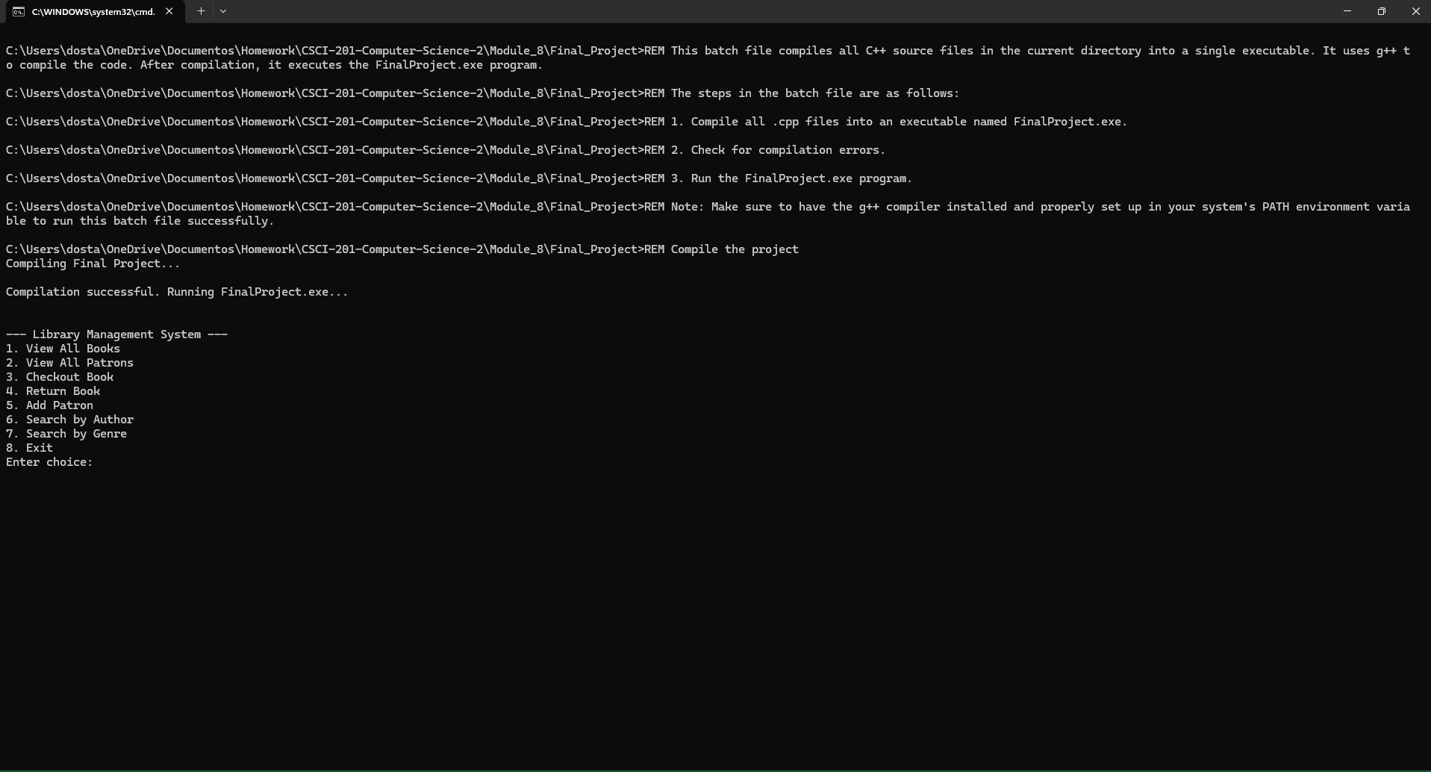
View All Books -
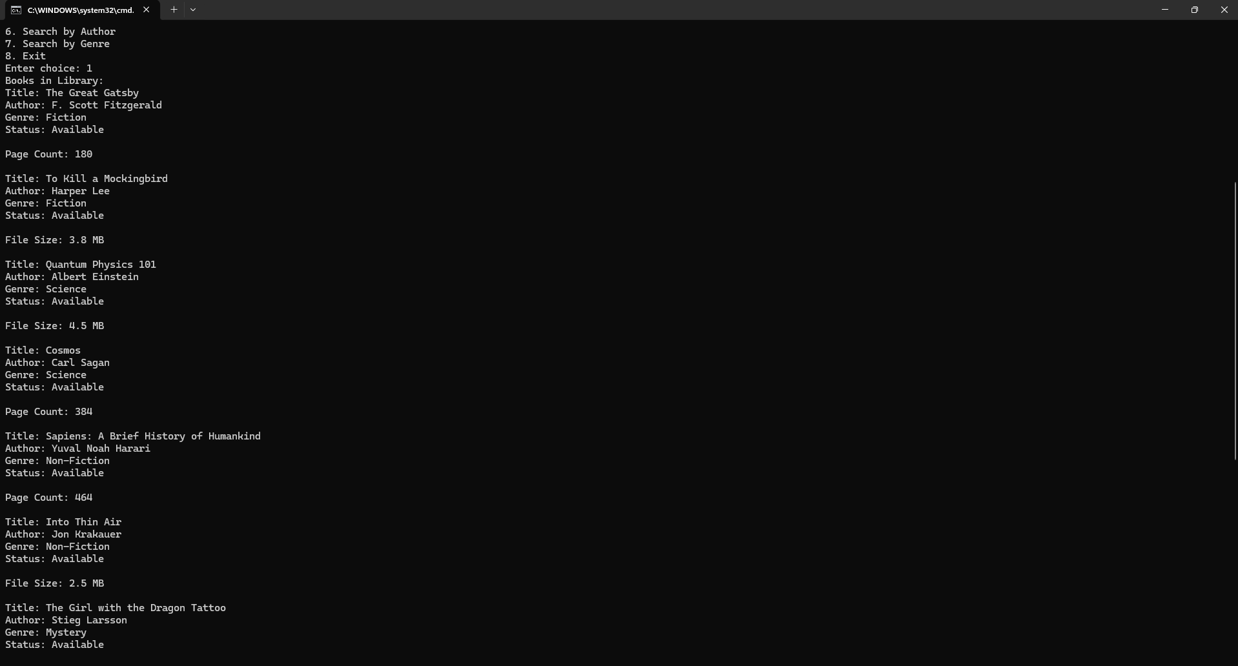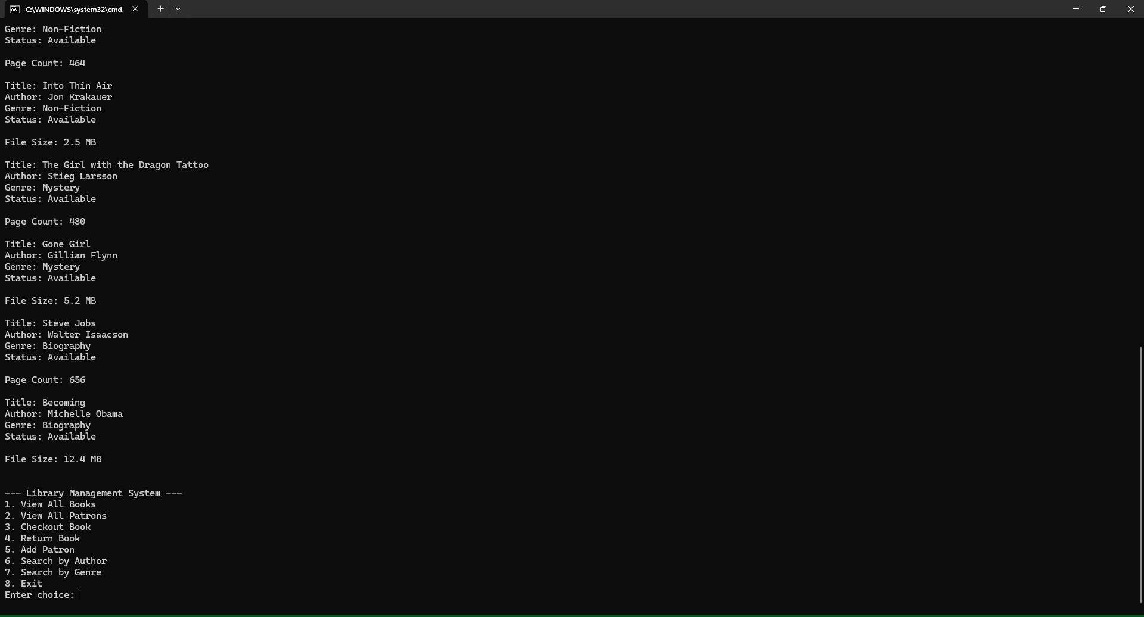
Checkout Book -
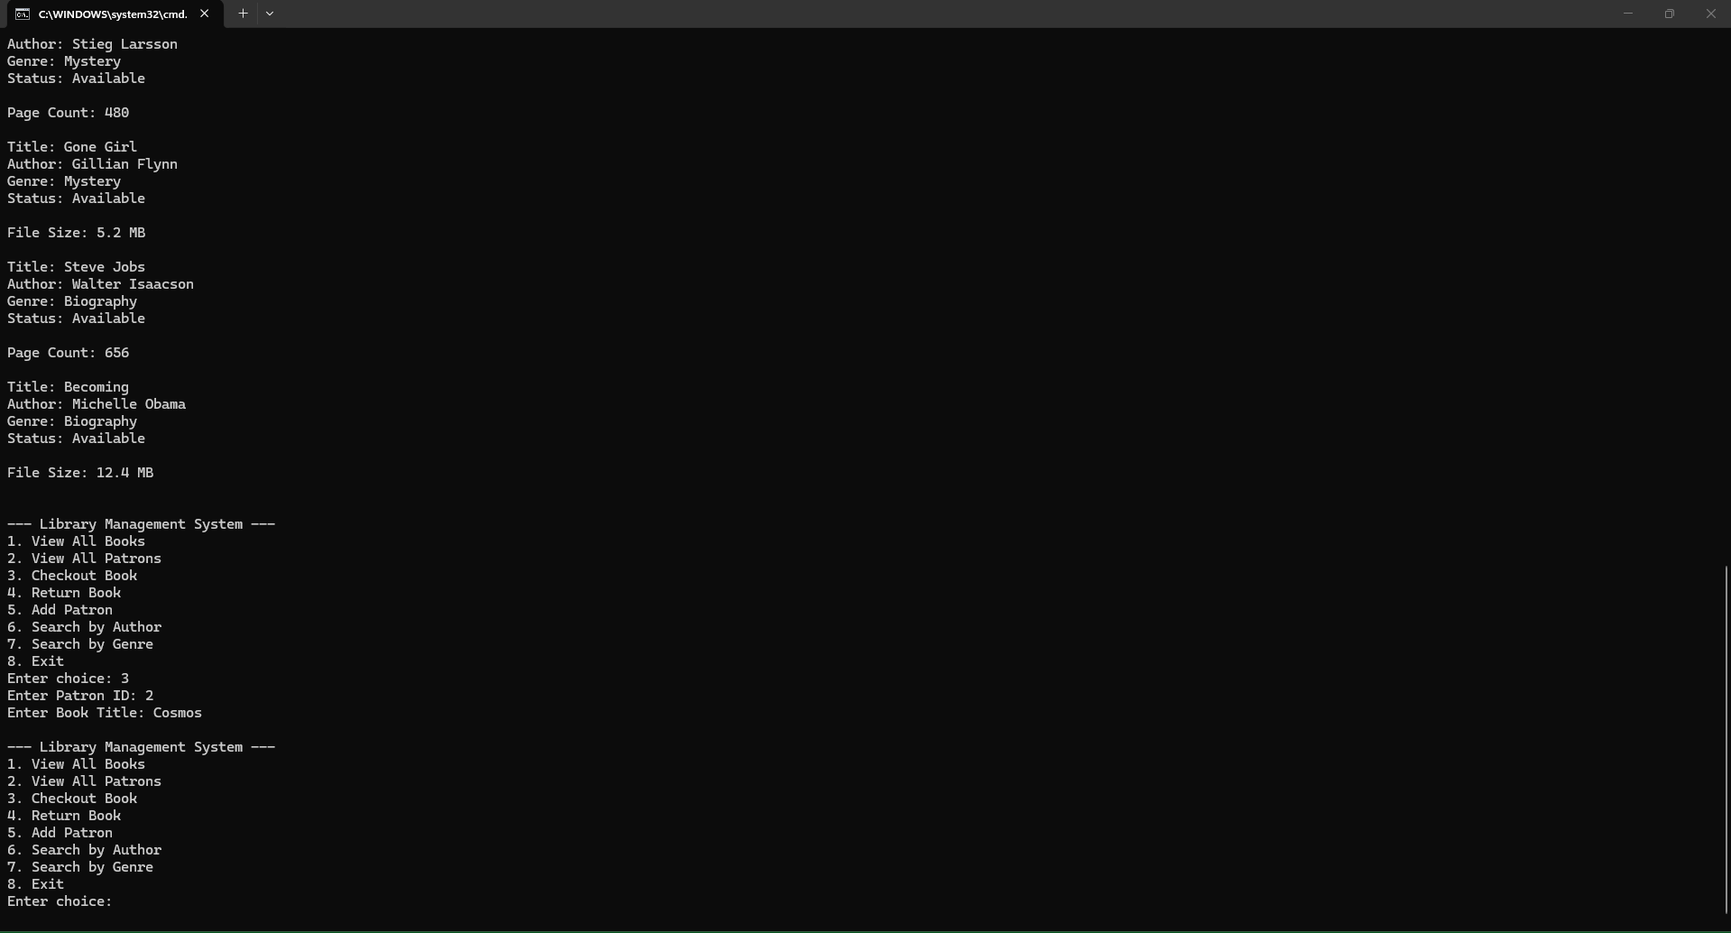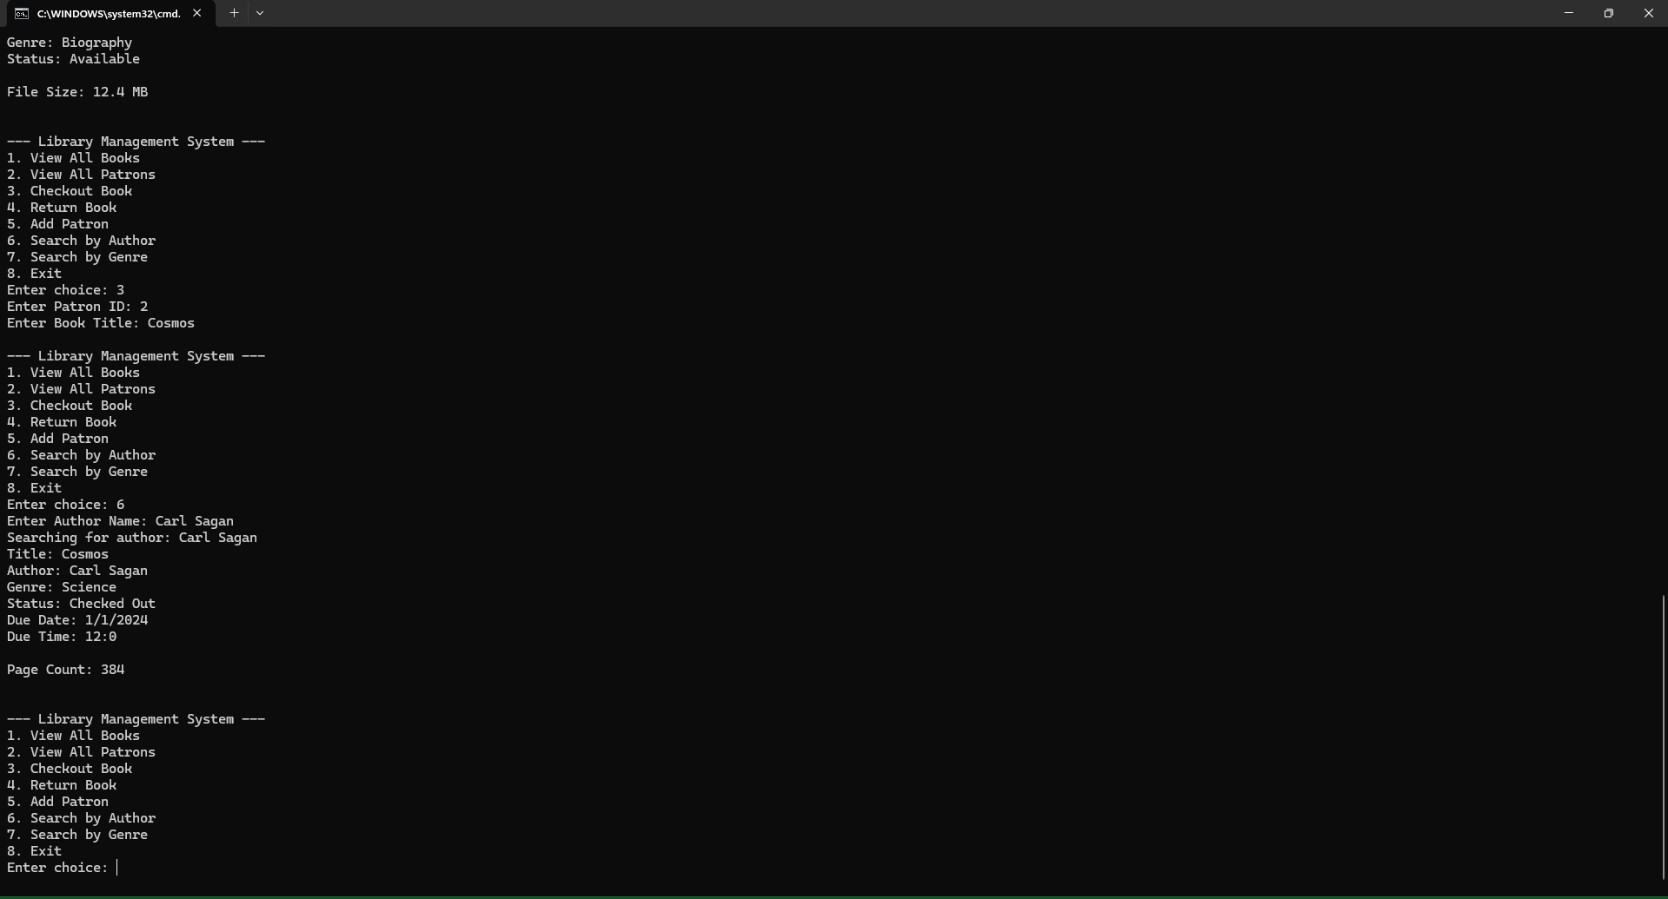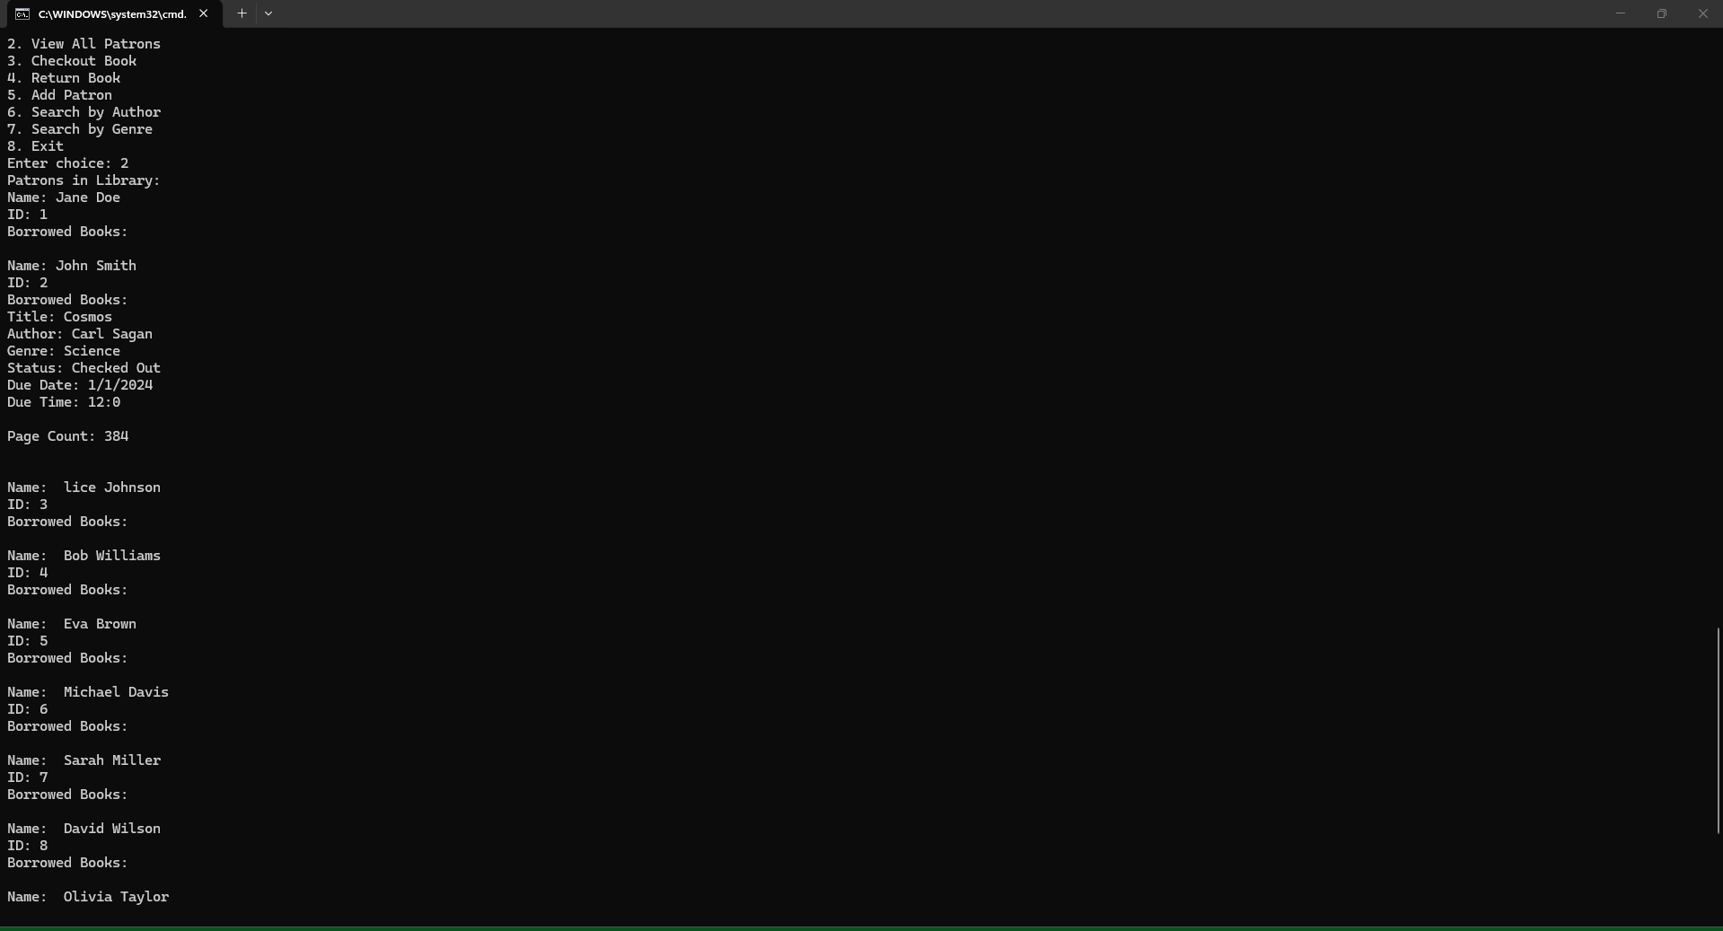

Save and Exit -
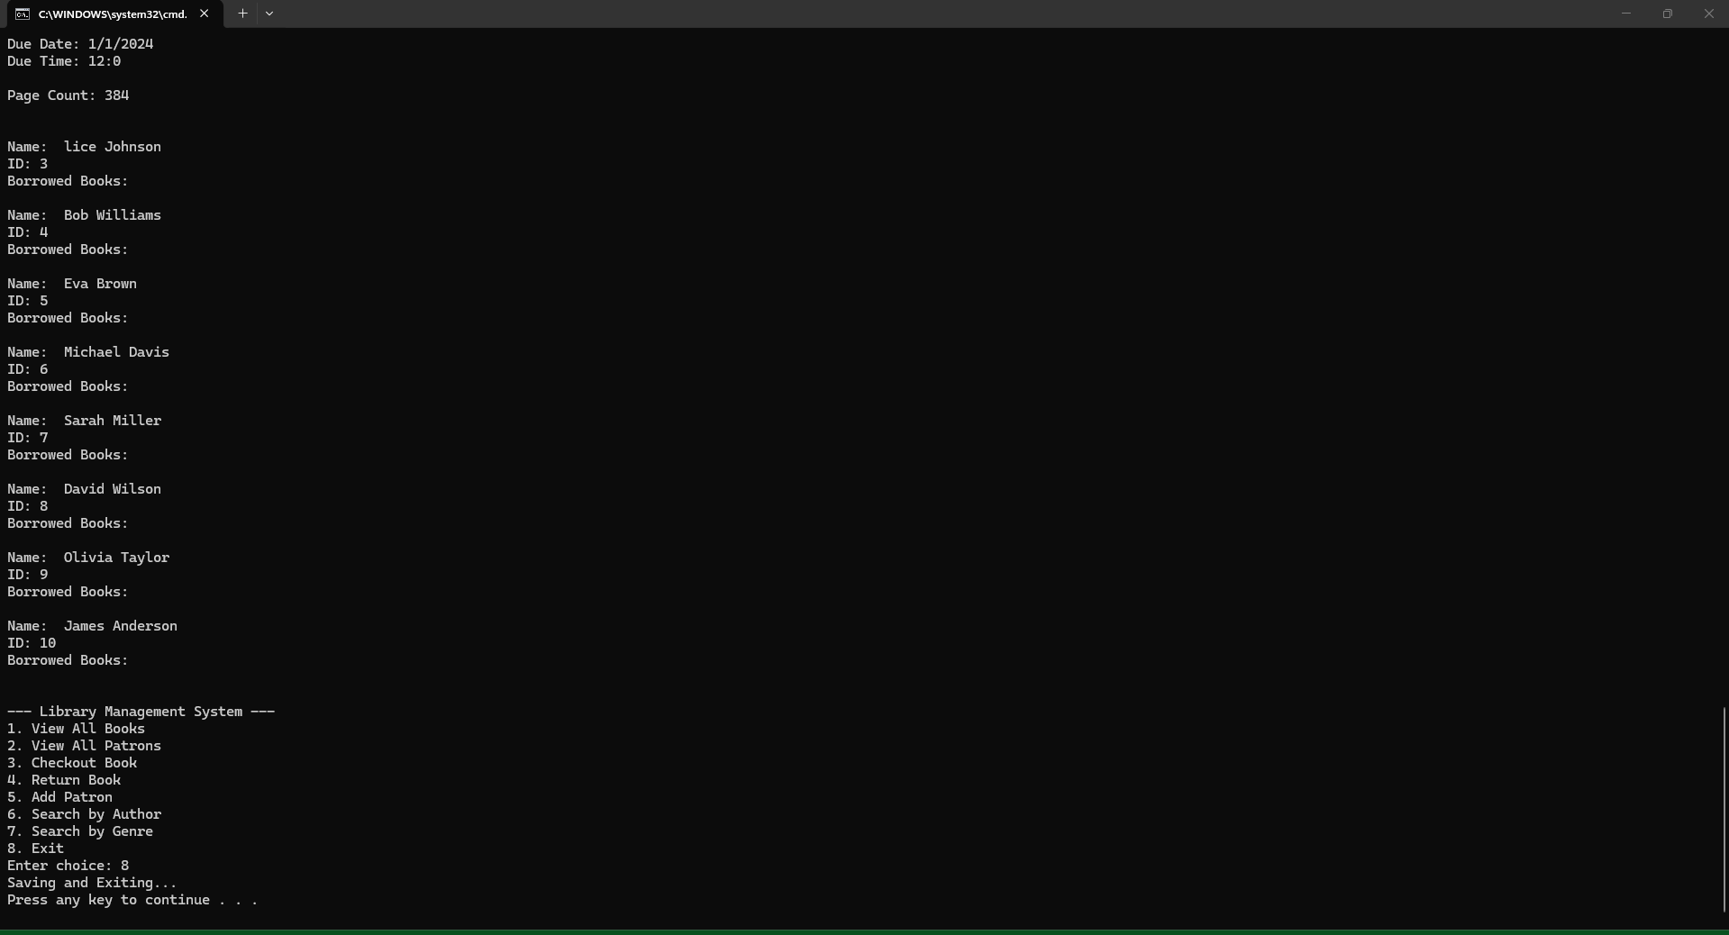
Transaction Log -
